Week-6 HW1

Q31:

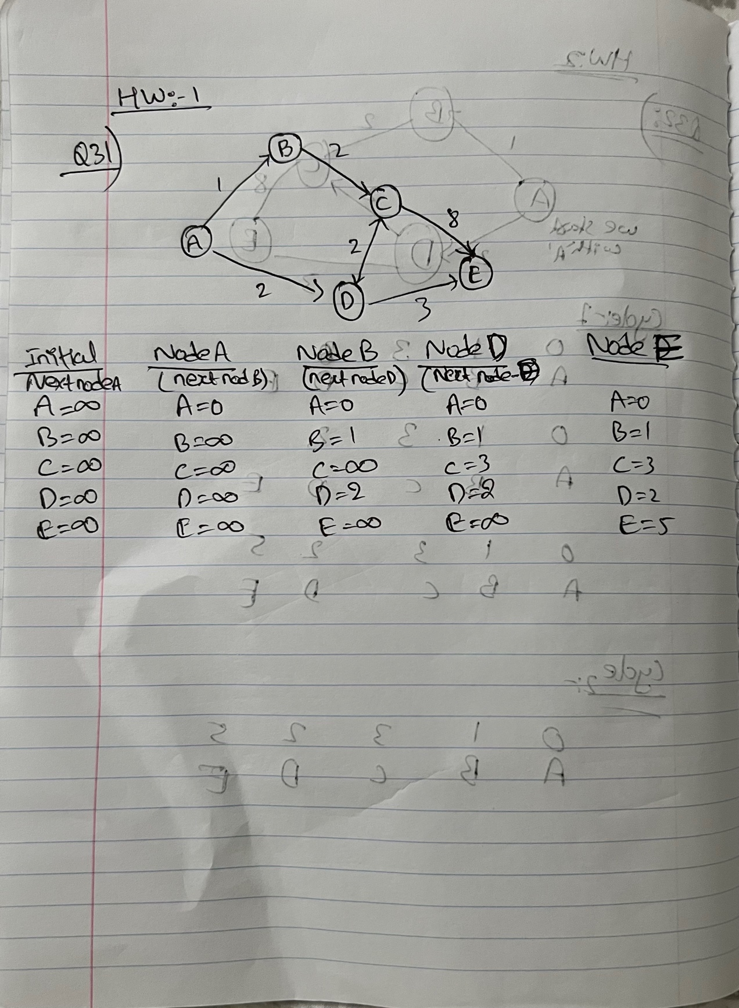

ChatGPT code:

Test code:

Output:

